**Lab Practical #02:**

Study of different types of network cables & connectors and practically implement the cross-wired cable and straight through cable using clamping tool.

**Practical Assignment #02:**

1. List various networks cable and connectors. Also, write short description.
2. Give cross-wired cable and straight through cable diagram (Color Code wise).

## List various networks cable and connectors. Also, write short description.

1. **Network Cable Name:** Coaxial Cable (RG-6/RG-59)
   * **Network Cable Type:** Guided
   * **Description**: A coaxial cable is an electrical cable with a copper conductor and an insulator shielding around it and a braided metal mesh that prevents signal interference and cross talk. Coaxial cable is also known as **coax.**
   * Coaxial cables are commonly used for cable TV and broadband internet connections. They have a central conductor surrounded by insulation, a metallic shield, and an outer protective layer.
   * **Diagram**:

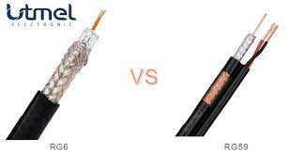

1. **Network Cable Name:** USB Cable (Universal Serial Bus)
   * **Network Cable Type:** Guided
   * **Description**: The term USB stands for "Universal Serial Bus". USB cable assemblies are some of the most popular cable types available, used mostly to connect computers to peripheral devices such as cameras, camcorders, printers, scanners, and more.
   * USB cables are primarily used for connecting peripheral devices, such as printers, keyboards, and external storage devices, to computers. They also support networking through USB-to-Ethernet adapters.
   * **Diagram**:

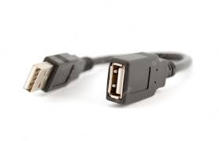

1. **Network Cable Name:** Fiber Optic Cable
   * **Network Cable Type:** Guided
   * **Description**: A fiber-optic cable contains anywhere from a few to hundreds of optical fibers within a plastic casing. Also known as optic cables or optical fiber cables, they transfer data signals in the form of light and travel hundreds of miles significantly faster than those used in traditional electrical cables.
   * **Diagram**:



1. **Network Cable Name:** Twisted Pair Cable
   * **Network Cable Type:** Guided
   * **Description**: Twisted pair cable is a type of network cable that consists of pairs of insulated copper wires twisted together in a specific pattern. It is widely used in Ethernet networks for transmitting data signals.
   * **Diagram**:

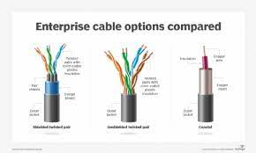

1. **Network Cable Name:** HDMI Cable (High-Definition Multimedia Interface)
   * **Network Cable Type:** Guided
   * **Description**: HDMI cables are used to transmit audio and video signals between devices, such as computers, game consoles, Blu-ray players, and TVs. They support high-definition video and multi-channel audio.
   * **Diagram**:

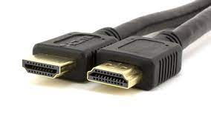

1. **Network Cable Name:** DisplayPort Cable
   * **Network Cable Type:** Guided
   * **Description**:DisplayPort cables are commonly used to connect computers and displays, such as monitors and projectors. They support high-definition video and audio signals.
   * **Diagram**:

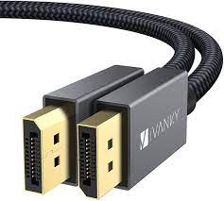

1. **Network Cable Name:** Thunderbolt Cable
   * **Network Cable Type:** Guided
   * **Description**:Thunderbolt cables provide high-speed data transfer and video output capabilities. They are commonly used for connecting external devices, such as storage drives and displays, to computers.
   * **Diagram**:

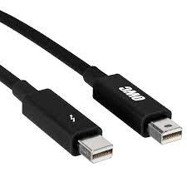

1. **Network Cable Name:** T Type Connecter
   * **Network Cable Type:** Guided
   * **Description**:A fiber-optic cable contains anywhere from a few to hundreds of optical fibers within a plastic casing. Also known as optic cables or optical fiber cables, they transfer data signals in the form of light and travel hundreds of miles significantly faster than those used in traditional electrical cables
   * **Diagram**:

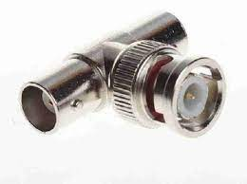

1. **Network Cable Name:** RJ-45 connecter
   * **Network Cable Type:** Guided
   * **Description**:: A fiber-optic cable contains anywhere from a few to hundreds of optical fibers within a plastic casing. Also known as optic cables or optical fiber cables, they transfer data signals in the form of light and travel hundreds of miles significantly faster than those used in traditional electrical cable.
   * **Diagram**:

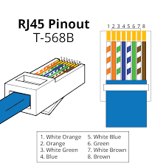

## Give cross-wired cable and straight through cable diagram (Color Code wise).

1. Cross-wired Cable Diagram (Color Code)

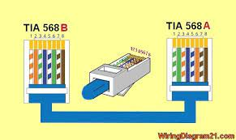

1. Straight Through Cable Diagram (Color Code)

